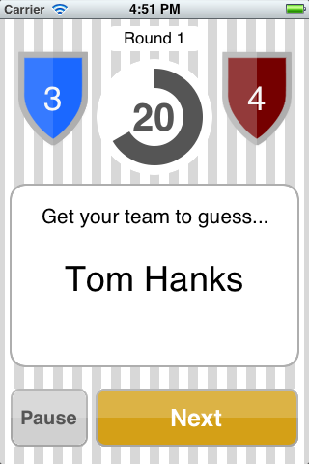

Current Round

Hit this button when your team guesses correctly to move on to the next name

The name your team must guess

Timer: when it expires, the other team is up

Team 2’s Score

Team 1’s Score